**Assignment -1**

**G SAI DEEPAK**

**192311432**

**CSA 5196**

* **Cryptography and security network for mobile applications**

**1.**

def caesar_cipher(text, k, encrypt=True):

    result = ""

    for char in text:

        if char.isalpha():

            shift = k if encrypt else -k

            base = ord('A') if char.isupper() else ord('a')

            result += chr((ord(char) - base + shift) % 26 + base)

        else:

            result += char  # Non-alphabetic characters remain unchanged

    return result

# Example usage

text = input("Enter text: ")

k = int(input("Enter shift (1-25): "))

while not (1 <= k <= 25):

    print("Shift value must be between 1 and 25.")

    k = int(input("Enter shift (1-25): "))

encrypted_text = caesar_cipher(text, k, encrypt=True)

print(f"Encrypted: {encrypted_text}")

decrypted_text = caesar_cipher(encrypted_text, k, encrypt=False)

print(f"Decrypted: {decrypted_text}")

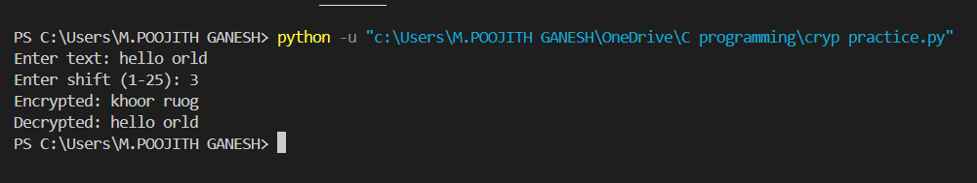

**2.**

import random

import string

# Function to generate a random substitution key

def generate_key():

letters = list(string.ascii_lowercase)

shuffled = letters[:]

random.shuffle(shuffled)

return dict(zip(letters, shuffled))

# Function to encrypt using the monoalphabetic substitution cipher

def encrypt(plaintext, key):

ciphertext = ""

for char in plaintext.lower():

if char in key:

ciphertext += key[char]

else:

ciphertext += char # Keep non-alphabetic characters unchanged

return ciphertext

# Function to decrypt using the monoalphabetic substitution cipher

def decrypt(ciphertext, key):

reverse_key = {v: k for k, v in key.items()} # Reverse the key mapping

plaintext = ""

for char in ciphertext.lower():

if char in reverse_key:

plaintext += reverse_key[char]

else:

plaintext += char # Keep non-alphabetic characters unchanged

return plaintext

# Generate a random substitution key

key = generate_key()

# Example plaintext

plaintext = "hello world"

ciphertext = encrypt(plaintext, key)

decrypted_text = decrypt(ciphertext, key)

# Output results

print("Substitution Key:", key)

print("Plaintext:", plaintext)

print("Ciphertext:", ciphertext)

print("Decrypted Text:", decrypted_text)

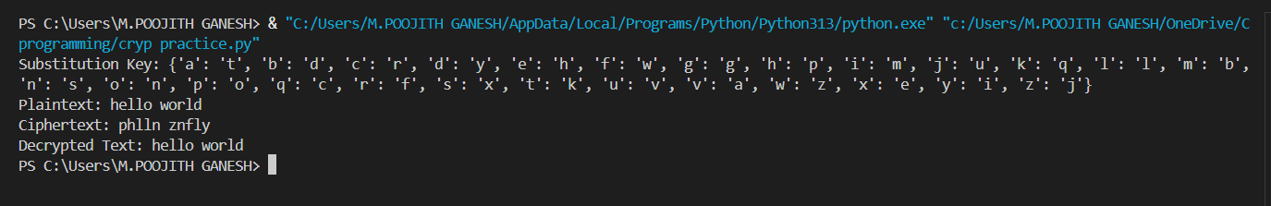

**3.**

import numpy as np

# Create Playfair matrix

def create_playfair_matrix(key):

key = "".join(dict.fromkeys(key.upper().replace("J", "I"))) # Remove duplicates, replace J with I

alphabet = "ABCDEFGHIKLMNOPQRSTUVWXYZ"

matrix = [c for c in key + "".join(c for c in alphabet if c not in key)]

return np.array(matrix).reshape(5, 5)

# Find position of a letter in the matrix

def find_position(matrix, letter):

pos = np.where(matrix == letter)

return pos[0][0], pos[1][0]

# Encrypt a digraph using Playfair rules

def encrypt_digraph(matrix, digraph):

a, b = digraph

row1, col1 = find_position(matrix, a)

row2, col2 = find_position(matrix, b)

if row1 == row2: # Same row

return matrix[row1, (col1 + 1) % 5] + matrix[row2, (col2 + 1) % 5]

elif col1 == col2: # Same column

return matrix[(row1 + 1) % 5, col1] + matrix[(row2 + 1) % 5, col2]

else: # Rectangle swap

return matrix[row1, col2] + matrix[row2, col1]

# Encrypt message

def playfair_encrypt(message, key):

matrix = create_playfair_matrix(key)

message = message.upper().replace("J", "I").replace(" ", "")

if len(message) % 2 != 0:

message += "X" # Padding if odd length

ciphertext = "".join(encrypt_digraph(matrix, message[i:i+2]) for i in range(0, len(message), 2))

return ciphertext

# Example usage

key = "CIPHER"

plaintext = "MUSTSEEYOUOVERCADOGANWESTCOMINGATONCE"

ciphertext = playfair_encrypt(plaintext, key)

print("Playfair Ciphertext:", ciphertext)

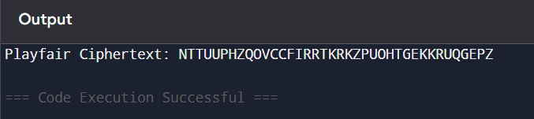

**4.**

from collections import Counter

def frequency_analysis(ciphertext):

    freq = Counter(ciphertext)

    sorted_freq = sorted(freq.items(), key=lambda x: x[1], reverse=True)

    return sorted_freq

# Example usage

ciphertext = "ZEBRAS ARE BEAUTIFUL ANIMALS"

freq_list = frequency_analysis(ciphertext.replace(" ", ""))

print("Letter frequencies:", freq_list)

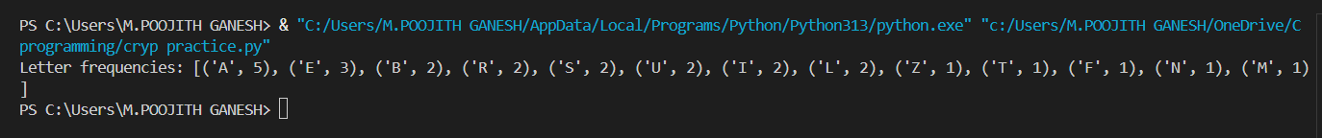

**5.**

import string

def generate_cipher_alphabet(keyword):

    keyword = "".join(dict.fromkeys(keyword.upper()))  # Remove duplicates

    alphabet = string.ascii_uppercase.replace("J", "")  # Playfair-style alphabet

    cipher_alphabet = keyword + "".join(c for c in alphabet if c not in keyword)

    return dict(zip(string.ascii_uppercase, cipher_alphabet))

def monoalphabetic_encrypt(plaintext, keyword):

    cipher_map = generate_cipher_alphabet(keyword)

    return "".join(cipher_map.get(c, c) for c in plaintext.upper())

# Example usage

keyword = "CIPHER"

plaintext = "HELLO WORLD"

ciphertext = monoalphabetic_encrypt(plaintext, keyword)

print("Monoalphabetic Ciphertext:", ciphertext)



**6.**

import numpy as np

# Convert text to number indices

def text_to_numbers(text):

return [ord(c) - ord('A') for c in text.upper().replace(" ", "")]

# Convert number indices back to text

def numbers_to_text(numbers):

return "".join(chr(n % 26 + ord('A')) for n in numbers)

# Encrypt using Hill cipher

def hill_encrypt(plaintext, key_matrix):

numbers = text_to_numbers(plaintext)

numbers += [0] * (len(numbers) % 2) # Padding for even length

numbers = np.array(numbers).reshape(-1, 2)

encrypted = (np.dot(numbers, key_matrix) % 26).flatten()

return numbers_to_text(encrypted)

# Example usage

key_matrix = np.array([[9, 4], [5, 7]]) # Given key

plaintext = "MEETMEATUSUALPLACE"

ciphertext = hill_encrypt(plaintext, key_matrix)

print("Hill Ciphertext:", ciphertext)

